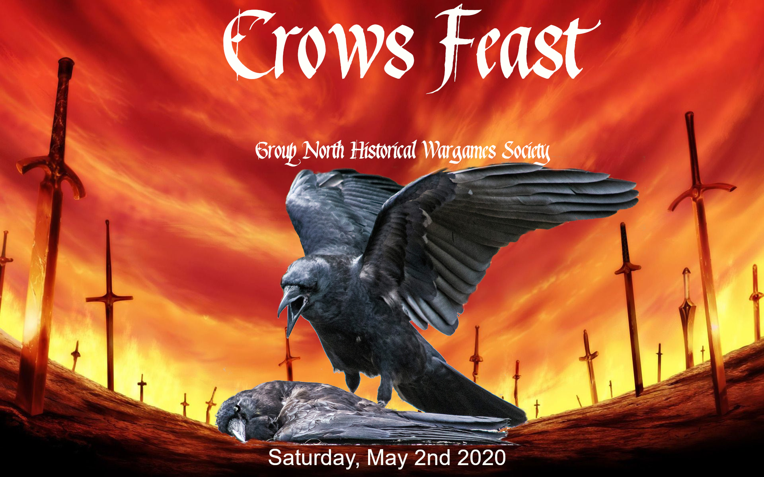
The Crows Feast is back to determine the best South Australian Kings of War champion. This will be a full day of gaming in the fantasy wargame that is gaining in popularity all over the world. Run on May 2nd the event will use Kings of Wars 3rd edition rules and the latest Mantic FAQ.

This is players pack 1.0.

Entry:
Entry is open to all club members and members of the public. Club members pay a $10 entry fee, non-club members pay $15.

The event will run for 3 games if there are 12 or less participants. If there are 13 or more entries at the 9:00am start time there will be a fourth game for the day. The earlier you can notify of attendance the better participants will be able to judge how long the day will run for. A minimum of 6 entries is required for the event to run.

Entry can be paid in cash to Lance Holden by arrangement or before the start of the competition. Money can also be transferred to the following account.
Bank: Adelaide Bank
Acct: 071580868
BSB: 610-101
Please indicate your name when submitting the payment. PayPal invoices available on request.

Email crowsfeast@groupnorth.club details of the payment. You will be emailed when the payment is received.

Venue:
The competition will be held at the Group North Historical Wargames Society venue. This is the A.E. Martin Hall on Woomera Avenue, Penfield.

Games:
08:30 – Venue Open
09:00 to 11:00 – Game 1 (Invade)
11:00 to 13:00 – Game 2 (Loot)
14:00 to 16:00 – Game 3 (Raze)
16:00 to 18:00 – Game 4* (Kill)
18:00 – Final results announcements
* Game 4 is only played if there are 13 or more participants at the start of the event.

The game scenario's are the standard missions as described in the Kings of War rulebook.

Games will be a fixed 6 rounds. Each game will be timed at 110 minutes per round. When time is called no new round can be started. There will be a five minute period for the current turn to end (so that both players have had an equal number of turns). After this five minute grace period dice are down and the turn ends immediately; any outstanding Nerve checks can be made.

No timing clocks will be used. Deployment will be included in the game time.

Players not at the venue by start of the first round will be considered to have a loss for the first round and generate 0 points of Attrition.

Due to the length of the day if a game is completed earlier than the allocated time all remaining games will be adjusted to start earlier. Each game remains at 110 minutes in a 2 hour window.

The club will have snack food available. There are take away food areas that can be reached during the lunch break. There are microwave and fridge's available for any self brought food.

Army composition:
Armies must not exceed 2000 points. They can be formed from any army released in the Kings of War 3rd edition Rulebook or the Uncharted Empires 3rd edition supplement. Unit composition will be based on the rules in the Kings of War rulebook. Allies are allowed.

Miniatures should meet the recommended minimum of 50%+1 of the model count for the unit size. Unit base size may exceed the specified base size but not by more than 10mm in any edge. Warmachines and Monsters may be on larger bases if required by the model.

Miniatures used must clearly differentiate between unit types. Where a proxy unit differs significantly from the normal look of the unit (such that a casual observer couldn't tell what unit they represent) the armies owner must provide unit cards that can be placed on the table to allow an opponent to know what the unit is at all times. An opponent can request this at any time. When unsure about a miniature you are invited to send in photo's to avoid having a unit disqualified on the day.

As determined by the TO any units on invalid bases, incorrectly size or not correctly assembled can not be fielded. The supplied army lists can't be changed. If in doubt contact the TO before the competition for exemptions. The TO has the final say on whether a unit is allowed.

All army lists are open between players. Players must provide the TO with a physical copy of the list on the day and then allow their opponent access to a copy of the list at any time during a game. Any questions about unit capabilities or movement ranges must be answered as quickly as possible.

Any invalid lists that are submitted will see the player receive a Loss for each played and current game and their opponent a Win. The player may correct the list before the next match but must be able to field appropriate units as defined above. A player can continue with less than the maximum number of points and field a valid army.

Rule Clarifications:
The FAQ will be used to clarify rules. Where there are disputes the Tournament Organiser (TO) will determine the outcome.

Scoring:
Players are randomly allocated to matches in the first round. Subsequent rounds are ordered by a players total points with the top pair playing each other, then the next top pair and so on. Players will not have to play each other twice and reordering will be done if this occurs. Where players have equal tournament points (TPS) they will be ranked randomly.

Rounds will be scored using the Black-Jack system. The Step 1 to Step 3 modifiers will be used.

The player results are ordered by the tournament points at the end of the games. If there is a draw then a player that has defeated the other player will be ranked higher.

Competition points will be tracked on the Tabletop.TO event.

Painting:
Crows Feast is considered a premier Kings of War event and wants to reward players who take the time to prepare armies for the spectacle of wargaming.

Painting score is determined by the TO before the start of the first round. The painting score will award between 0 and 5 bonus points. The scoring guidelines are listed below.

Points Guidelines
0-1 Army not fully assembled, based or painted beyond undercoating. Some units may have paint started or basic base decoration.
2-3 Majority of units painted with a simple level of detail (basic washes and highlights included), bases have details (painted, decoration, etc.). Some units make be incomplete but started to be painted.
4 All models painted to a very good standard (shading, highlighting, picked out details, complementing bases) and individuals given extra attention. Linked theme throughout the army.
5 An army painted to an excellent standard with high level of detail on all models.
The scoring system is subjective but should be guided by the above bands. Armies will be compared against each other to determine which is the exceptional standard. Only the models are to be considered, not any movement tray associated with the army.

Tables and terrain:
Terrain will be set on the table and already be described in its game terms (height, obstacles, etc.). Players are not to deliberately reposition terrain and must attempt to return terrain that is moved to its original position.

Players are randomly allocated to a table. Players may be on the same table for multiple games in the competition. At the start of a game both players will dice to determine their starting side as normal.

Prizes:
The player at the end with the highest score from all the rounds will receive the best general award. Where the top players have the same score if they have played each other the winner of that bout receives the generals award. If they haven't met the combined tournament points of all their opponents will be added and the player with the highest opponent count will win. All other players on the same score will be considered equally ranked.

Other prizes donated by sponsors will be announced as available. Some prizes may be raffled off over breaks.

Food:
The venue has snack food, soft drinks and water available for purchase. If you leave the venue to collect food and aren't back before the starting time of the round your opponent wins a victory and you have a defeat. Mircowave and ovens are available for use.

No Liquor License is being applied for this event. You will not be able to consume alcohol at the venue.

Updates:
Details of the event and any changes will be announced at GroupNorth.club or Facebook.

This is players pack version 1.0. Future rules changes will increase the whole number, corrections or clarifications will increase the decimal part. The previous release had the old event date.


